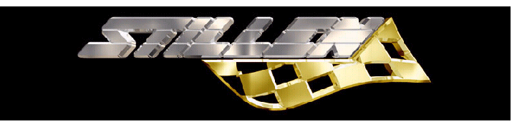

Part # AP1600

Application: 1998-00 Chevrolet Corvette C5

Suggested List $3339.00

Notes:
- 18" wheels required with minimum pad height clearance of TBA"= dimension A
and an inner diameter clearance of 15.35"

Front: AP Racing 6 Piston Caliper
- Light weight cast aluminum
- Fixed mount for minimal caliper flex
- sequentially sized pistons (2 X 27/32/38) minimizes pad taper and maximizes even friction
- Anti rattle springs reduce pad noise
- Inner wiper and dust seals for everyday use

AP Racing (355mm X 35.5 mm) Rotors
- Directionally curve vein vented for maximum cooling
- Cross-drilled and Slotted for aggressive pad bite and proper out-gassing
- Two piece modular disc

Brake Pad
- Pad area 76.3cm squared X 2 per caliper
- Pad material designed for high performance street and track use
- Consistent friction of co-efficient at low and high temperatures

Replacement parts:

- Part # AP000D51 - Ferodo Brake Pads
- Part # AP00050L- Cross-Drilled & Slotted Rotor
- Part # AP00050R- Cross-Drilled & Slotted Rotor

